German NIS2 Implementation Act Compliance for Log360
Tagline: Meet Germany's NIS2 requirements with real-time threat detection from Log360.

Overview
The German NIS2 Implementation Act (NIS2UmsuCG) Compliance extension for Log360 helps German essential and important entities meet the cybersecurity risk management, supply chain security, and incident reporting obligations introduced by Germany's national NIS2 transposition.
Log360 collects and correlates logs from IT systems, operational technology, cloud platforms, and network infrastructure, mapping events to NIS2 control requirements. Security and compliance teams can continuously monitor their environments, detect incidents within mandatory reporting timelines, and generate audit evidence for BSI and sectoral supervisory authorities.

Key Features
- Generate audit reports mapped to NIS2UmsuCG requirements covering risk management controls, access monitoring, incident detection, and supply chain oversight.
- Detect and correlate NIS2-relevant security incidents in real time with automated BSI reporting templates, enabling organizations to meet mandatory 72-hour incident notification requirements for essential and important entities.
- Centralize log data from across your infrastructure to maintain real-time visibility into user activity and access patterns, supporting proactive threat identification and German NIS2 compliance posture.
- Export compliance documentation in PDF and CSV formats for BSI incident notifications, supervisory authority submissions, and internal governance.
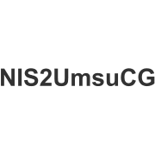


Screenshots
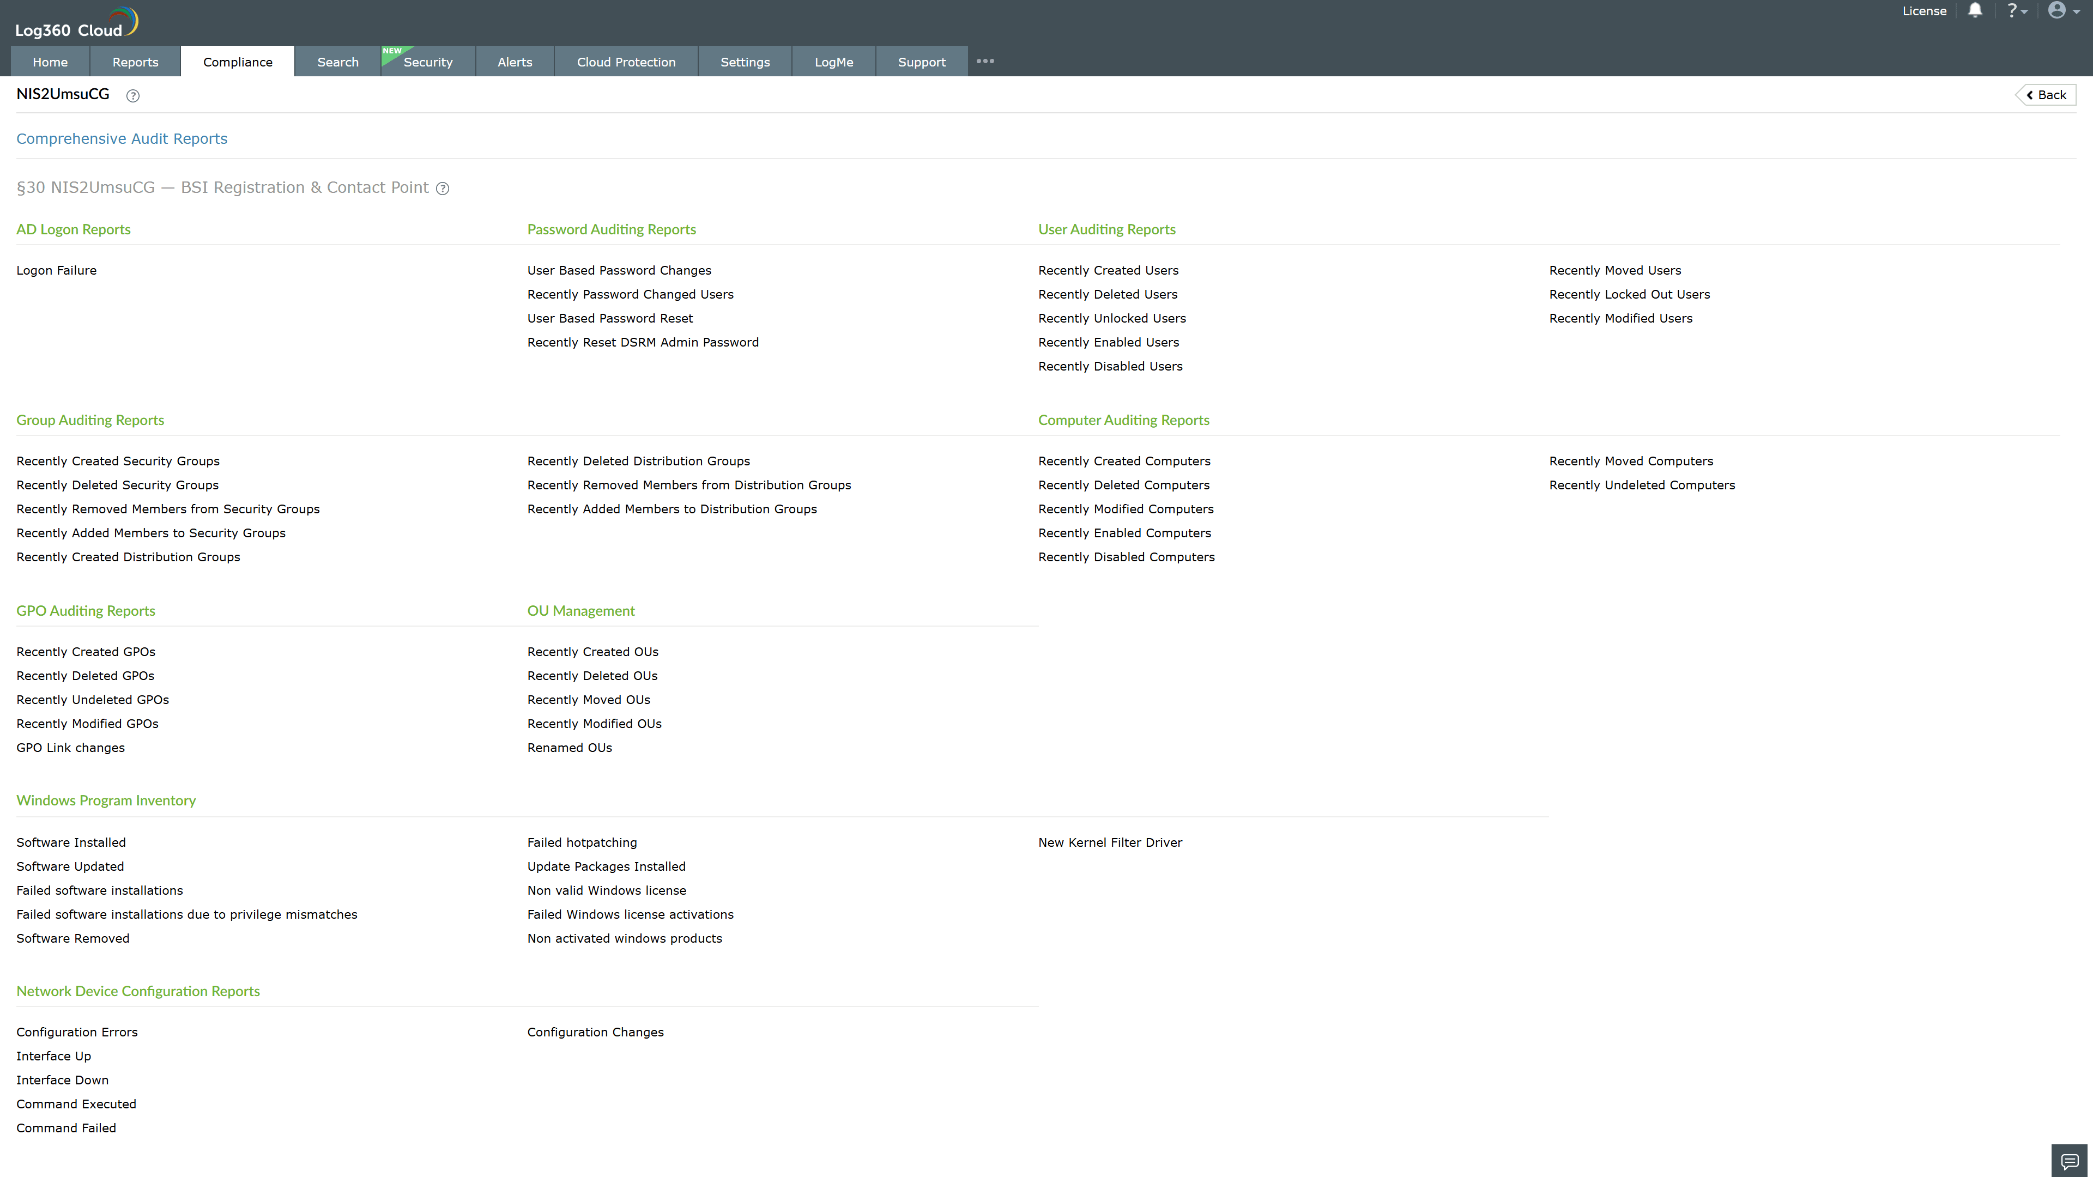
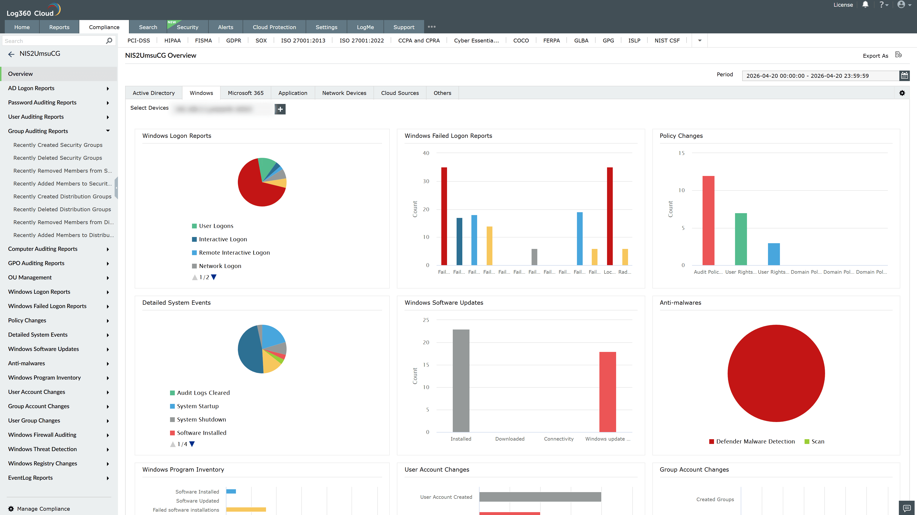
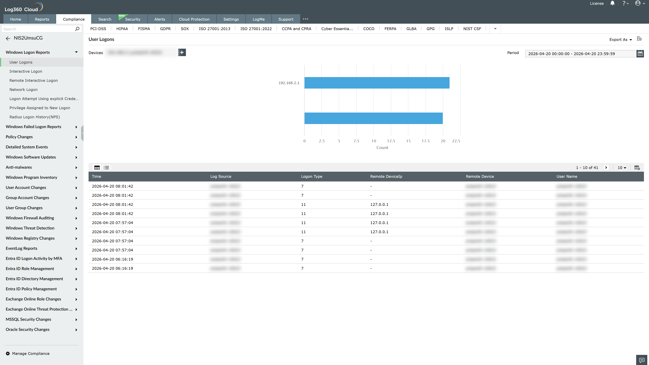
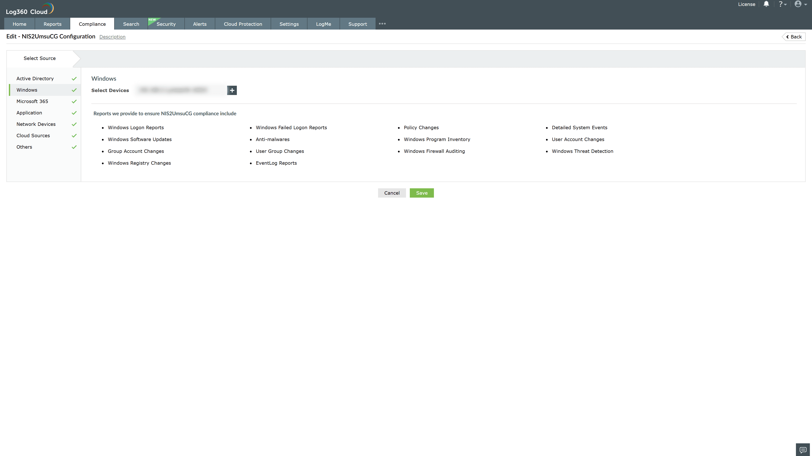
Valid Submission : Yes
Supported Editions : Free, Basic, Standard, Professional, MSSP
Help Document : https://www.manageengine.com/log-management/help/integrations/compliance-extensions.html
Help Video : Not provided
Tags : Log360, Compliance, Privacy monitoring, Data privacy, Regulatory compliance
Supported DCs : US, IN, JP, CA, AU, UK and EU
Privacy Policy:
Terms of Service:
Release Notes:
Predefined reports for the german nis2 implementation act nis2umsucg compliance

